

January 2025

November and December are always busy months for us with our Christmas parcel campaign. Thank you to everyone who participated again this year. We gave out 1520 gifts to seafarers from around the world. Many seafarers sent us messages of thanks and appreciation, so I am letting their words speak for themselves. This is a small sampling of the messages and photos we received. I hope that you can see the effect a small gift has on the lives of men and women from around the world.

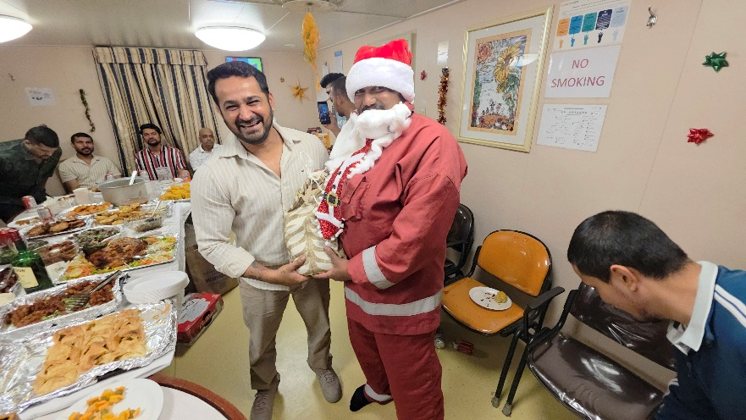
Seasons greetings , My name is Robinson G Fernandes from India, I am a seafarer for the past 13 years. I am very greatful for the love, care and concern that the Ministry of Seafarer's has shown me and other Seafarer's in the form of Christmas parcels. I was also touched to receive a hand written Christmas greeting card from Rita at CWL. St Jean de Brebeuf (Montreal ministry to Seafarer's) this is the first Christmas greeting card that I have ever received in my life I will preserve it with me for the rest of my life. I wish I could wish her back a Merry Christmas too.
Over the years I have experienced a lot warmth and care from the Ministry of Seafarer's and I feel proud as Christian when I see how you portray our faith to the world.
I hope this email finds you well
Once again thank you for your support. God bless.
Good day,
This email is only to thank your organization for the kindness and consideration.
Our Vessel visited Montreal on 12-14th December 25.
During our Port stay someone from your organization delivered 19 presents to my deck crew.
When my deck crew brought the bags with presents inside I asked where they had come from, and if the persons bringing the present where still on board.
The answer was no – they just said: I saw on the crew list that you where 19 crew on board, so we brought 19 presents.
It was very cold and snowy at the time.
Our crew is mixed from several countries: Our Captain is from Croatia, Myself and the 3rd officer is from Denmark, Our Chief Engineer, 3rd Engineer and 2nd Officer are all from Philippines, our 2nd Engineer is from Ukraine and the 4th engineer as well as all our Ratings on deck and in engine room are from India – so you can imagine that we all have different traditions regarding Christmas.

We have been working very hard before – and as well as now after Christmas – we have had a lot of unforeseen issues on board that we have had to deal with, and we have not had the possibility to relax around Christmas.

But we saved the presents from your organizations for Christmas eve. I put them all under the Christmas tree in the morning - and I had numbered all presents and each crew member also draw a number “from the hat” – then we handed out all presents so they match with a number and opened up the presents together. They where all in homemade fabric bags, which are perfect for storing your socks or underwear later on 😊
It was a lot of fun opening the presents and seeing the various items found in the bags. After opening presents we went on to share a good meal prepared by our Chief Cook – with helpers during the day
- And Just to explain: in Denmark it is tradition to open presents on Christmas Eve after holding hands, walking around the Christmas tree and singing Christmas Carols.

A heartfelt “Thank You” for your kindness and consideration from all the crew on Torm Strength – you all made a day a little brighter !

Best Regards – and Happy New Year
Line Grave Poulsen
Chief Officer - Torm Strength

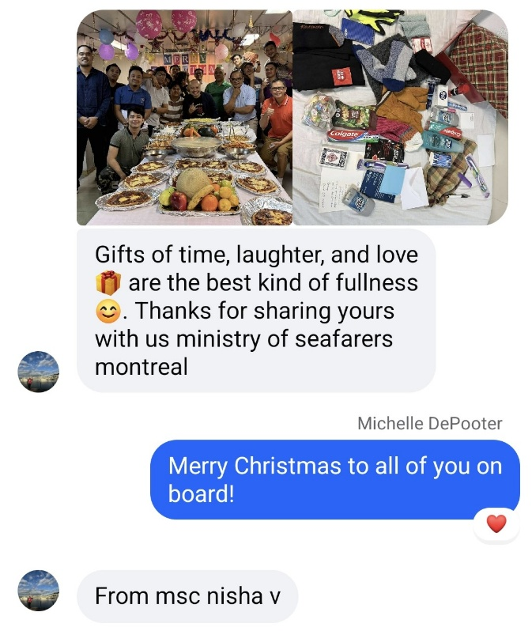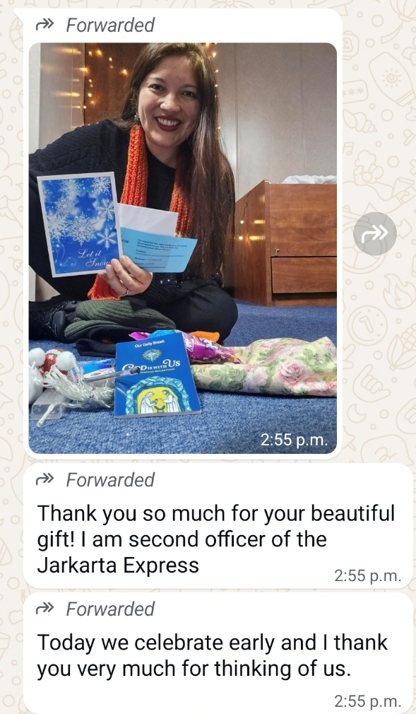

Thank you for your continued support and prayers as we serve seafarers throughout the year. May God bless each and every one of you in 2026!
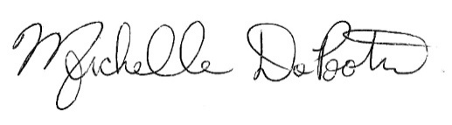
Michelle DePooter
M2S Chaplain

